Lab report 1

Step 1: Search “VScode download” on Google and click on the official VScode website, which will look like this:

Step 2: Click on the correct download button based on the operating system on your computer. Download and install the VScode. After successfully installed the VScode, open the VScode and it will look like this:

Step 3: Find your CSE15L account in this link: [**https://sdacs.ucsd.edu/~icc/index.php**](https://sdacs.ucsd.edu/~icc/index.php) and reset your password. Open your terminal in VSCode and type “ssh [“+ your account+”@ieng6.ucsd.edu](mailto:“+%20your%20account+”@ieng6.ucsd.edu)” and push the return button on your keyboard. Then type “yes” and push the return button. Then typed the password of your CSE15L account and push the return button. You will see something like this:

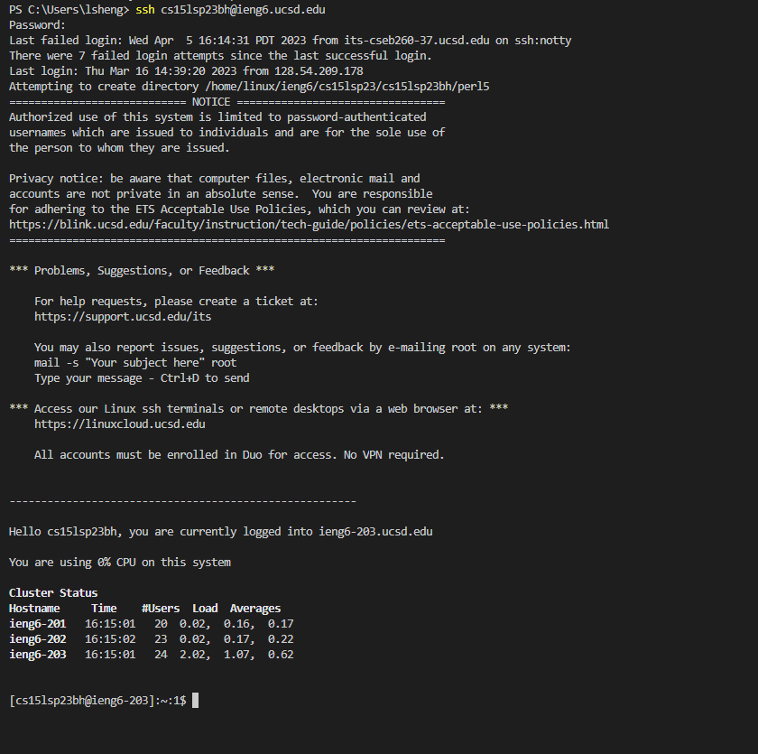

I did not get my password right at first, so the terminal keeps asking me to enter password again and again. Finally I get my password right and I get the message that inform me how many failed attempts I have as shown in the image above.

Step 4: Try some command in your terminal such as “cd ~”, “cd”, “ls -lat” and “ls -a”. Push the enter button on your keyboard each time you complete a command. You will see the output of your command in your terminal just like this:

